**The Hodgkin-Huxley Model and the Refractory Period of a Neuron**

**By: Joshua Strauss and Aadya Agrawal**

**Abstract :**

This project explores action potentials using the Hodgkin-Huxley model. This is a mathematical model that treats the neuron like a circuit to describe how action potentials are initiated and propagated using a set of differential equations. The project will explore the refractory period of a neuron (the time taken by a neuron to return to its resting potential after an impulse has passed) and its dependance on parameters like channel conductance, membrane capacitance, resting potential etc. by varying each parameter individually. Results show that the leak channel conductance and membrane capacitance have the greatest effect whereas, sodium and potassium channel capacitance have a smaller effect.

**Motivation:**

Beyond neurons and action potentials being a really cool example of how circuits and electromagnetism apply to our own bodies, refractory periods within neurons are especially interesting because they display the complex, physical constraints that biological systems have to deal with. On a biological importance note, refractory periods provide the neuron time to recover neurotransmitters it has used, so it can effectively signal the next neuron.

**Background:**

To begin, it's important to understand what a neuron is and why they are important. Neurons are the information carriers of the nervous system. They are cells that carry messages in the brain and throughout the body; without them, we would not be able to use our bodies or minds. These messages travel in the form of electrical impulses called action potentials. Action potentials are the focus of our model and work. When an action potential reaches the end of the neuron it sends a signal (via neurotransmitters) to either the next neuron or a muscle cell if it's at the end of its journey. The next neuron would only fire another continuing action potential if the amount of signals it gets brings its resting membrane potential (around -70mV) past the threshold (around -55mV).

The action potential works with two ion channels in the neuron, a sodium channel (with 2 gates) and a potassium channel (with 1 gate). This electrical impulse is just a travelling change in voltage. This change begins after the threshold is past and is called depolarization. Depolarization is where the sodium channel opens up and positive sodium ions rush in rapidly changing the negative voltage of the neuron to positive. Once the voltage becomes positive enough, repolarization occurs as the sodium channel is closed, and sodium can no longer enter the cell. During repolarization, the potassium channel opens and positive potassium ions flood out of the cell, making the neuron negative again.

The last stage of this process is hyperpolarization or the refractory period, which is what we will be measuring in our model. The potassium gates close slowly, so extra potassium leaves, sending the voltage more negative, past its resting potential. The time it takes to recover the membrane potential to the resting potential and get back the right ratio of potassium and sodium ions in the neuron is called the refractory period.

An additional factor to take into account is leakage/leak channels that exist in neurons. Neurons are naturally porous and leakage does occur during action potential, and these leak channels are what aid the neuron in returning to normal during the refractory period. These three phases depolarization, repolarization, and hyperpolarization travel through the wire-like neurons as the action potential.

The last variable, membrane capacitance, comes from the the neuron’s phospholipid bilayer membrane, which acts as a natural capacitor and with the resistance of the channels determines the membrane’s time constant, which determines how fast the neuron returns to normal (this determines the length of the refractory period -- what we are measuring).

The leak channel, potassium ion channel, and sodium ion channel act like a circuit in the Hodgkin Huxley model, which is further explained below. The model uses Kirschoff's Voltage and Current Rules and models different components such as resistors, capacitors, and multiple batteries.

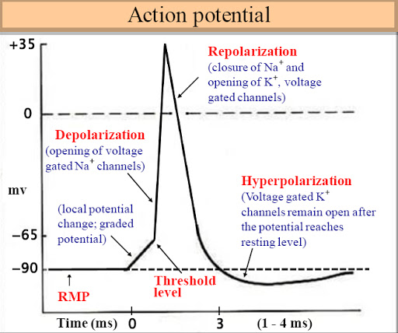

Stages of Action Potential with Channel Behaviour

**Model and Setup:**

Based on the Hodgkin-Huxley, we model the different parts of the neuron as a circuit. The different channels are modelled as resistors having variable resistance that are dependent on whether the ion channels are open or closed. The potential of the channels is dependent on the ion concentrations of each individual channel which is represented using a battery. The membrane encompassing the neuron is represented as a capacitor. Hence, we have the membrane, the sodium channel, the potassium channel and the leak channel represented as different branches of the parallel circuit with each individual branch having a resistance and battery.

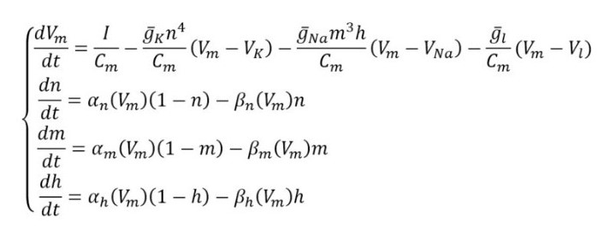 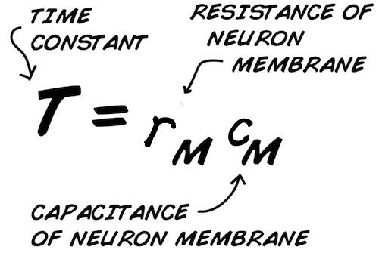

The above equations are modelled as a function, with Vm, gK, gNa, gl, Cm, n, m, h as input variables.

The code we used for our analysis was sourced from the internet.

(Link to our code : <https://github.com/aadya291/final-project>)

Results and Conclusion:

|  |  |
| --- | --- |
| gK | Refractory period (ms) |
| 5 | 9 |
| 20 | 11 |
| 36 | 11 |
| 50 | 12 |
| 70 | 12 |
| 150 | 13 |
| 500 | 13.5 |
| 1000 | 14 |

|  |  |
| --- | --- |
| Conductance of Leak Channel (mS/cm^2) | Refractory Period (ms) |
| 0 | N/A |
| 0.03 | 92 |
| 0.1 | 32 |
| 0.2 | 16.5 |
| 0.3 | 11.5 |
| 0.6 | 6.9 |
| 0.9 | 6.9 |

|  |  |
| --- | --- |
| gNa | Refractory period (ms) |
| 3 | 0 |
| 5 | 5 |
| 60 | 9 |
| 100 | 9 |
| 120 | 10.5 |
| 135 | 10 |
| 150 | 10 |
| 1000 | 11 |

|  |  |
| --- | --- |
| Membrane Capacitance (uF/cm^2) | Refractory Period (ms) |
| 0 | N/A |
| 0.05 | 5.8 |
| 0.1 | 5.8 |
| 0.5 | 8 |
| 1 | 11.5 |
| 1.3 | 16 |
| 1.8 | N/A |

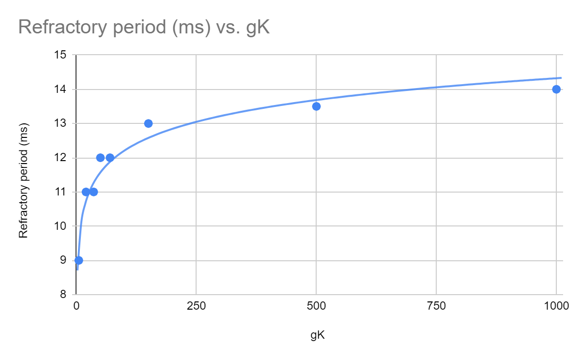

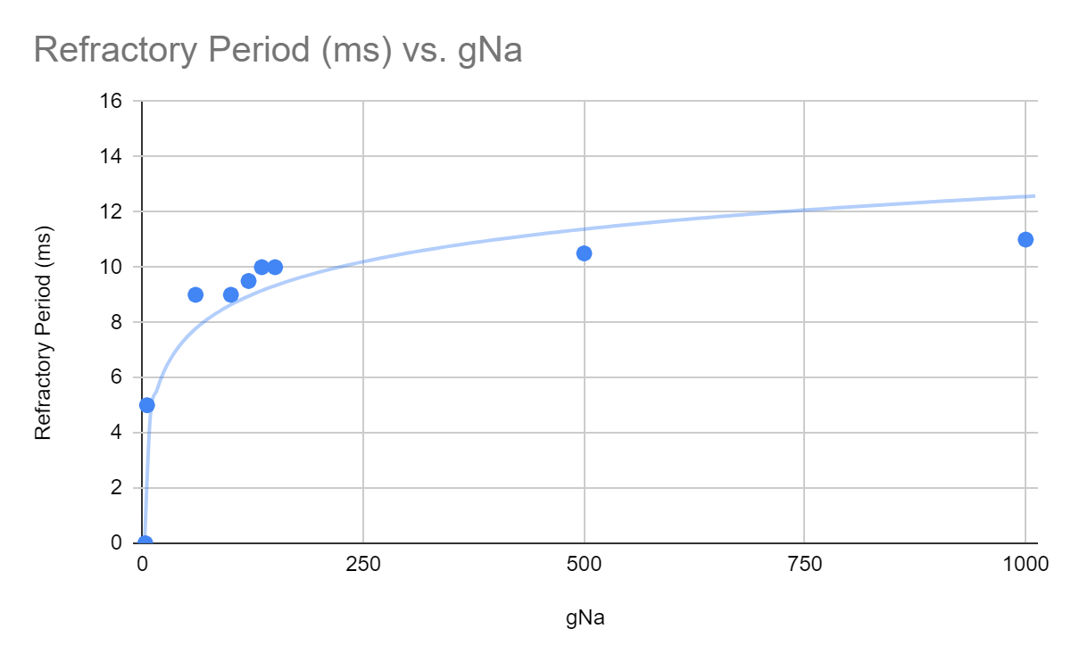

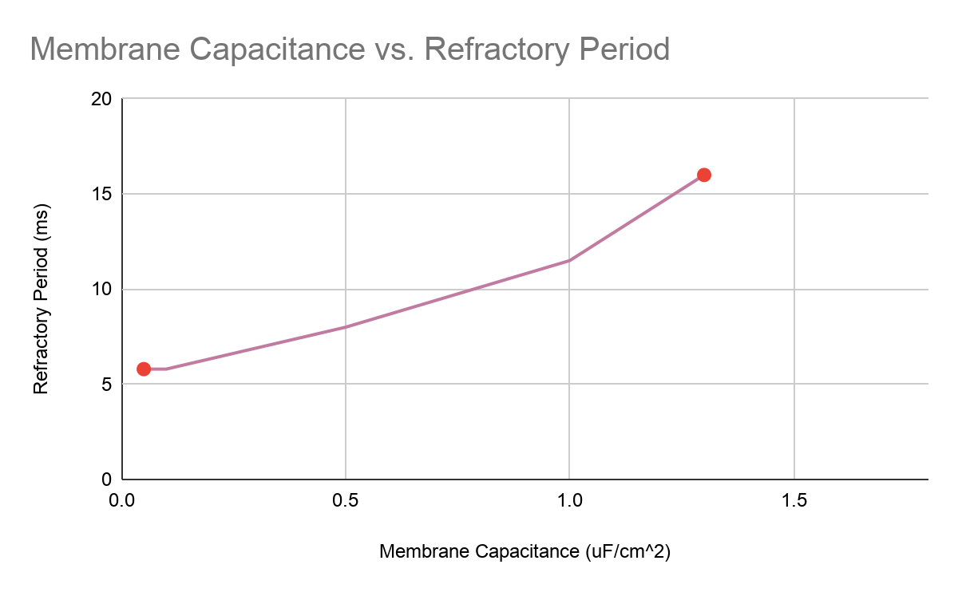

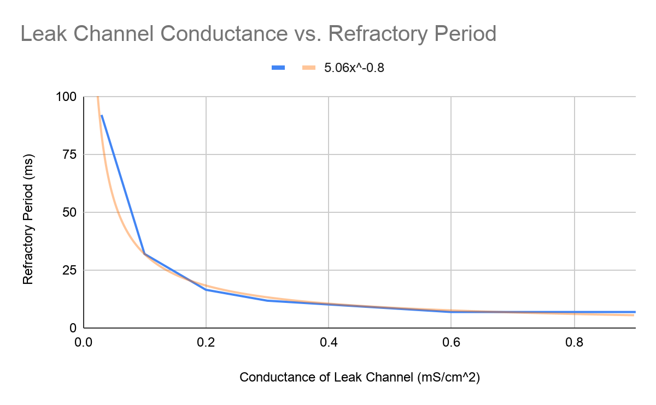

**Conclusions and Discussion:**

1. Sodium Channel Conductance and Potassium Channel Conductance: Our data shows that these two properties are both related to the refractory period by a logarithmic relationship. The ion channels themselves are in charge of depolarization and repolarization respectively and are closed during the refractory period, so otherwise don’t play that large a role in determining the length of the refractory period beyond being part of the process that creates it. Our data does show the conductances of these ion channels do have a minute effect -- that as the conductance increases the duration of the refractory period increases as well, to a levelling off point.This is because a high conductance makes the spike of the action potential slimmer, sharper, and of a shorter duration, which the refractory period to begin earlier causing the longer times. Physically, this represents how a higher conductance results in a higher current and faster flow of ions through the channels.
2. Leak Channel Conductance: The leak channel plays the most active role during the refractory period to recover the correct ratio of potassium and sodium ions to regain the resting membrane potential. The refractory period decreases as leak channel conductance increases by a power function of around (y = $5.06x^{-0.8}$). The leak conductance represents the entire resistance in the membrane time constant equation when using Kirchhoff's rules (the other channels are closed) and the time constant determines the rate the membrane will return to the resting potential. The faster the ions can travel, the faster the neuron recovers and the refractory period ends.
3. Membrane Capacitance: This model is valid only for a finite amount of values of the membrane capacitance. The membrane of the neuron needs to be able to hold charge, so the capacitance can not be equal to or less than 0. The reason it cannot be above 1.4 uF/cm^2 without breaking the action potential model is unclear. However, as it is an incredibly complex biological model, it is not unreasonable to believe that capacitance would be restricted by other factors. The slope of the graph itself shows a small positive relationship between the refractory period and the membrane capacitance. Similarly to the conductance of the sodium and potassium ion channels, this affects the refractory period much less than the leak voltage. The membrane capacitance affects the refractory period with the channel resistances (in our model conductances) by determining the membrane time constant, which helps determine how fast the membrane will return to its resting potential.

**Sources of Error**:

First, our model is a simplification of the actual biological process and is done on a computer both of which create room for possible error. Our time measurements came from reading graphs with our eyes, which creates the room for two separate systematic errors, which is why some measurements that should match don’t as to keep consistency with the dataset. We also did not use the exact right numbers for a neuron in terms of initial potentials (other than resting)

**Possible Improvements and Extrapolation**:

In the future, we could improve our model by including more complicated details and factors, like a threshold potential limiter. We could also explore how other organisms differ in neuron circuitry and different possible resting potentials.

**Sources and References:**

“Neuron Action Potentials: The Creation of a Brain Signal (Article).” *Khan Academy*, Khan Academy, www.khanacademy.org/test-prep/mcat/organ-systems/neuron-membrane- potentials/a/neuron-action-potentials-the-creation-of-a-brain-signal.

Golowasch J., Nadim F. (2014) Capacitance, Membrane. In: Jaeger D., Jung R. (eds) Encyclopedia of Computational Neuroscience. Springer, New York, NY

Hodgkin, Alan L., and Andrew F. Huxley. "A quantitative description of membrane current and its application to conduction and excitation in nerve." *The Journal of physiology* 117.4 (1952): 500-544.

262588213843476. “Hodgkin-Huxley Spiking Neuron Model in Python.” *Gist*, gist.github.com/giuseppebonaccorso/60ce3eb3a829b94abf64ab2b7a56aaef.

Distribution of Work:

The research for the project was done by both the members. The code was modified and tested by both and then the parameters that were to be tested were divided between the two. Joshua worked on the membrane capacitance and the leak conductance, while Aadya worked on the sodium and potassium channel conductances. The results were analyzed together. Joshua worked on the word document writeup and Aadya worked on the markdown writeup in the Python Notebook. All work was cross-checked by both parties before submission.